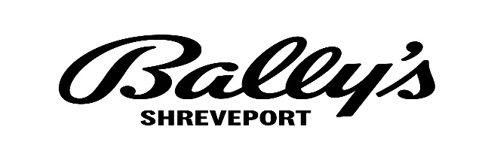
“Mystery Scratch Event”
Rules

- All individuals must be twenty-one (21) years of age or older with valid proof of age to qualify for and participate in the Bally Rewards Program.
- Participants cannot be included if he/she is on any excluded, management excluded, or self-excluded list. Individuals will be checked for eligibility.
- Valid photo identification, acceptable to Bally’s Shreveport Casino & Hotel, will be required for membership registration, activation, point redemptions, promotional offers and for obtaining any information with respect to the Bally rewards Club account.
- Selected Bally Rewards Club members will receive a mailer with a Voucher. Vouchers must be redeemed at designated redemption areas during the designated promotional periods below:
  - Friday, October 14, 2022, from 5:00 PM—9:00 PM
  - Saturday, October 15, 2022, from 12:00 PM – 5:00 PM
- The Voucher is valid during the above promotional times only. Guests wishing to redeem outside of the above times will forfeit their voucher prize amount.
- The Voucher scratch-off panel MUST be scratched off in the presence of a Bally’s Promotional Representative during one of the above stated promotional periods. Vouchers that are damaged or altered or that have already been scratched-off will be considered void.
- If the voucher is destroyed, lost, stolen or misplaced, no replacement voucher will be provided.
- Voucher is non-transferable. Valid identification must be presented along with Bally Rewards card and voucher to redeem prize amount.
- Prize amounts range from $5 up to $5,000 cash.
- Limit one (1) Voucher per person.
- Employees of Bally’s Shreveport Casino & Hotel and its subsidiaries, affiliates, or parent companies and immediate family members are not eligible to participate in the promotion.
- Management reserves all rights to change, modify or cancel this promotion at any time without prior notification, with regulatory approval.

Gambling Problem? Call 1-877-770-STOP.

