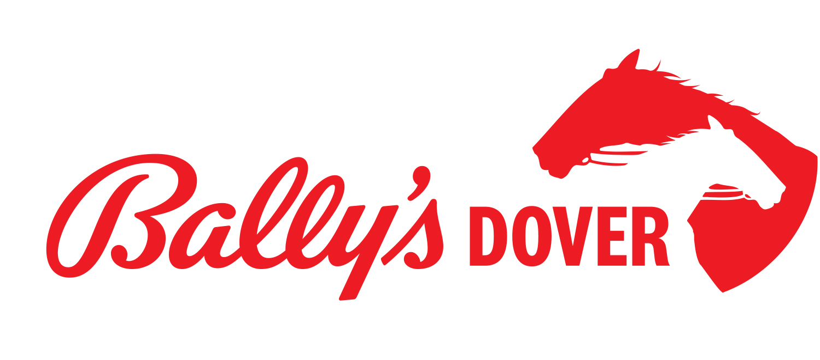
2025 - 2026
Stakes Schedule

Progress Pace
Date | Day | Event | Est. Purse
11/20 | Thursday | 3-Year-Old Pace Elim/Preview | $35,000
11/26 | Wednesday | 3-Year-Old Pace Final | $250,000

Matron Series
Date | Day | Event | Est. Purse
11/6 | Thursday | 2-Year-Old Filly Trot Final | $138,000
11/6 | Thursday | 2-Year-Old Colt Trot Final | $138,000
11/6 | Thursday | 2-Year-Old Filly Pace Final | $138,000
11/6 | Thursday | 2-Year-Old Colt Pace Final | $138,000
11/13 | Thursday | 3-Year-Old Filly Pace Final | $116,550
11/13 | Thursday | 3-Year-Old Filly Trot Final | $146,050
11/13 | Thursday | 3-Year-Old Colt Pace Final | $185,500
11/13 | Thursday | 3-Year-Old Colt Trot Final | $152,000

2025 Delaware Standardbred Breeders Fund (DSBF)
Date | Day | Event | Purse
11/6 | Thursday | 2-Year-Old Colt Pace Elim 1 | $20,000
11/10 | Monday | 2-Year-Old Filly Trot Elim 1 | $20,000
11/11 | Tuesday | 2-Year-Old Colt Trot Elim 1 | $20,000
11/12 | Wednesday | 2-Year-Old Filly Pace Elim 1 | $20,000
11/13 | Thursday | 2-Year-Old Colt Pace Elim 2 | $20,000
11/17 | Monday | 2-Year-Old Filly Trot Elim 2 | $20,000
11/18 | Tuesday | 2-Year-Old Colt Trot Elim 2 | $20,000
11/19 | Wednesday | 2-Year-Old Filly Pace Elim 2 | $20,000
11/20 | Thursday | 2-Year-Old Colt Pace Final | $100,000
11/24 | Monday | 2-Year-Old Filly Trot Final | $100,000
11/25 | Tuesday | 2-Year-Old Colt Trot Final | $100,000
11/26 | Wednesday | 2-Year-Old Filly Pace Final | $100,000

12/1 | Monday | 3-Year-Old Filly Trot Elim 1 | $20,000
12/2 | Tuesday | 3-Year-Old Colt Trot Elim 1 | $20,000
12/3 | Wednesday | 3-Year-Old Filly Pace Elim 1 | $20,000
12/4 | Thursday | 3-Year-Old Colt Pace Elim 1 | $20,000
12/8 | Monday | 3-Year-Old Filly Trot Elim 2 | $20,000
12/9 | Tuesday | 3-Year-Old Colt Trot Elim 2 | $20,000
12/10 | Wednesday | 3-Year-Old Filly Pace Elim 2 | $20,000
12/11 | Thursday | 3-Year-Old Colt Pace Elim 2 | $20,000
12/15 | Monday | 3-Year-Old Filly Trot Final | $100,000
12/16 | Tuesday | 3-Year-Old Colt Trot Final | $100,000
12/17 | Wednesday | 3-Year-Old Filly Pace Final | $100,000
12/18 | Thursday | 3-Year-Old Colt Pace Final | $100,000

